Part 2- Binary Search Tree Questions

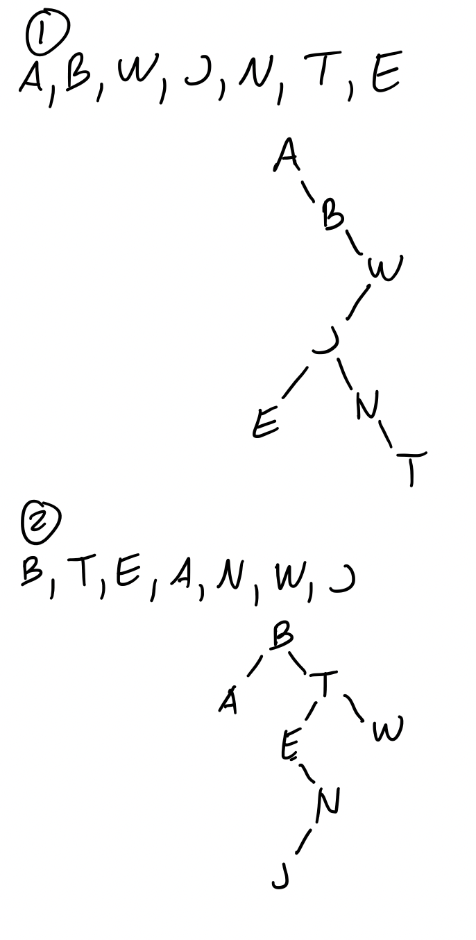

3.

Max number of nodes in a binary search tree of height 3: 7

Max number of nodes in a binary search tree of height 4: 15

Max number of nodes in a binary search tree of height h: 2h – 1

